Conference dinner:
6:45 – 10:45pm, November 10
Matteos
533 Brunswick St

Distance is 2.9km from conference venue (could walk in about 45 minutes, or allow 15 minutes by taxi. A taxi fare is estimated at between $10-$15).

Public transport options below.

Option 1: Bus (approx 17 minutes)

1. Walk from the conference venue to the bus stop on Swanston St

2. Take 546 bus towards Heidelberg, departing at 6:12pm

3. Get off at stop Nicholson St/Alexandra Pde

4. Walk about 300m to Brunswick St (turn left off Alexandra Pde)

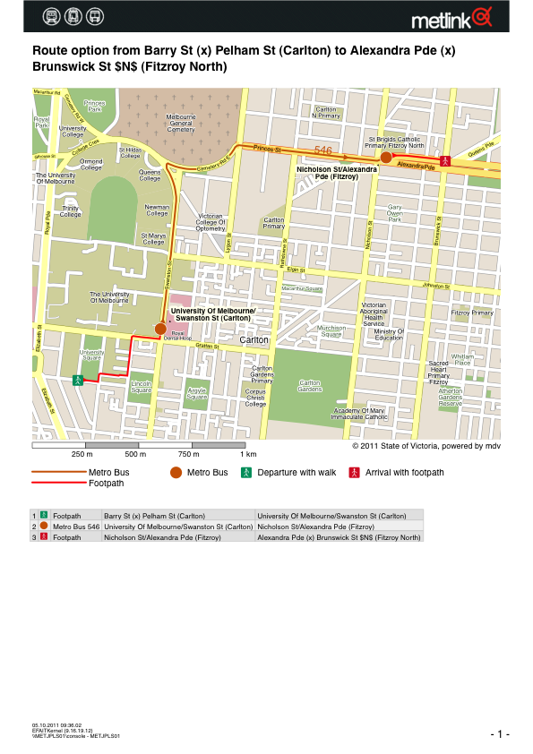

Option 2: Tram + walk option (approx 25 minutes)

1. Walk from the conference venue to the tram stop on Swanston St

2. Take 1 tram (towards Coburg) or the 8 tram (towards Moreland),

3. Get off at stop Princes St / Lygon St

4. Walk about 950m along Princes St-Alexandra Pde to Brunswick St (turn left off Alexandra Pde)

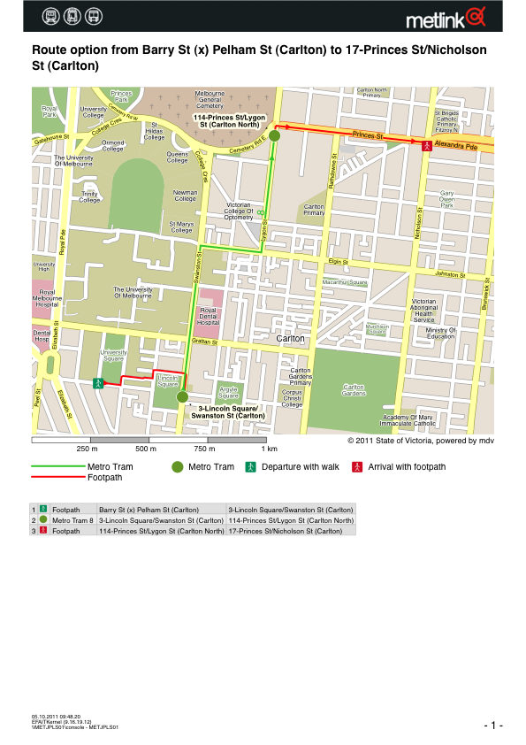

Option 3: Tram + tram (approx 31 minutes)

1. Walk from the conference venue to the tram stop on Swanston St

2. Take 1, 3, 3a, 6, 8, 16, 64, 67 or 72 tram towards city.

3. Get off at stop Collins St/ Swanston St

4. Walk to Melbourne Town Hall tram stop on Collins St.

5. Take the 112 tram towards Preston (travels along Brunswick St).

6. Get off at corner of Alexandra Pde and Brunswick St and walk to venue.

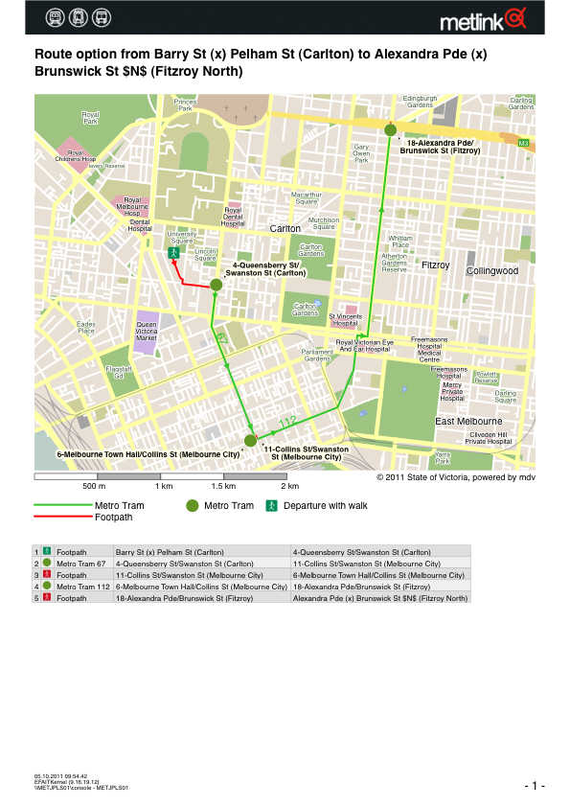

Returning from conference banquet

If you intend to catch public transport back from Matteo’s, please note the following timetable of city-bound services from North Fitzroy:

546 Bus: no city-bound option after 6:30 pm

1 Tram: Departs every 20 minutes until 11:57pm

8 Tram: Departs every 20 minutes until 12:07 am

112 Tram: Departs every 20 minutes until 12:12 am

Trams depart Collins St towards Melbourne University approximately every 5 minutes until 12:47am.

